Project Design Phase-II

Data Flow Diagram &User Stories

Date 16 October 2022
Team ID PNT2022TMID24391
Project Name Project - Plasma Donor Application
Maximum Marks 4 Marks

Data Flow Diagrams:

A Data Flow Diagram (DFD) is a traditional visual representation of the information flows within a system. A neat and clear DFD can depict the right amount of the system requirement graphically. It shows how data enters and leaves the system, what changes the information, and where data is stored.

Example: DFD Level 0 (Industry Standard)

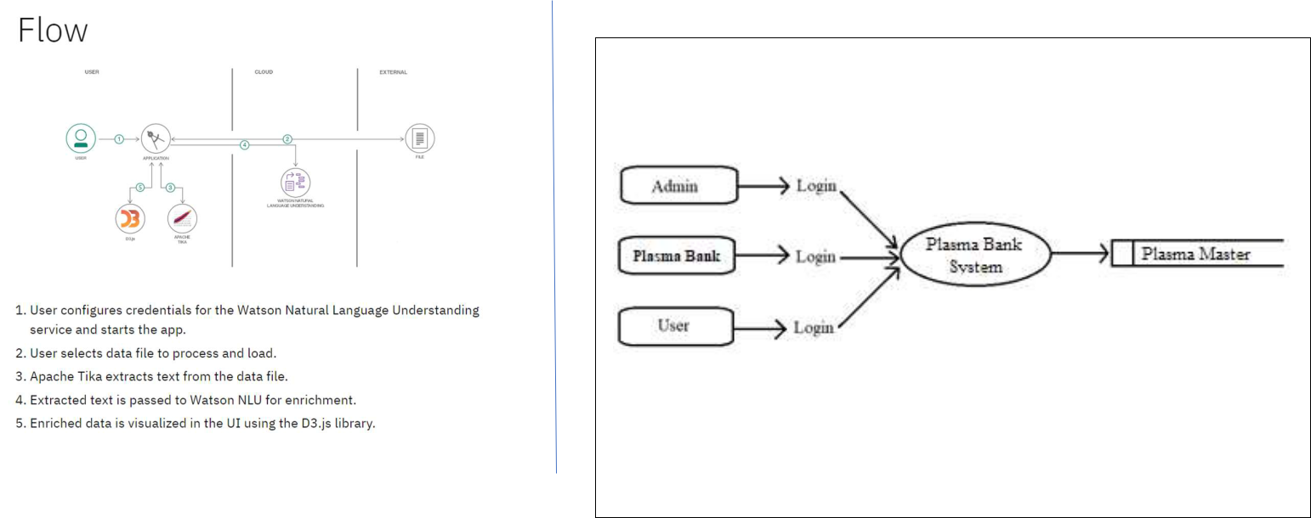

Example: (Simplified)

Level 0

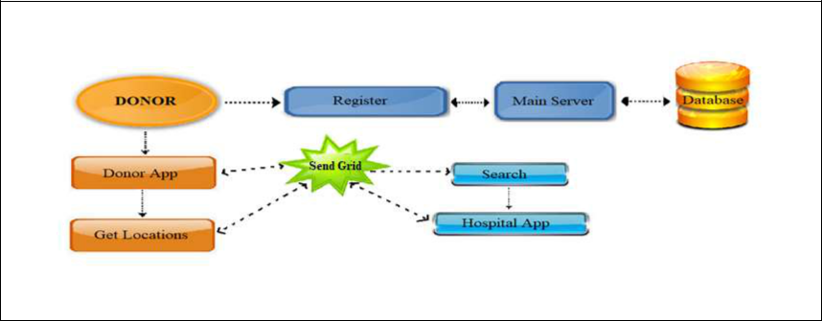

Level 1
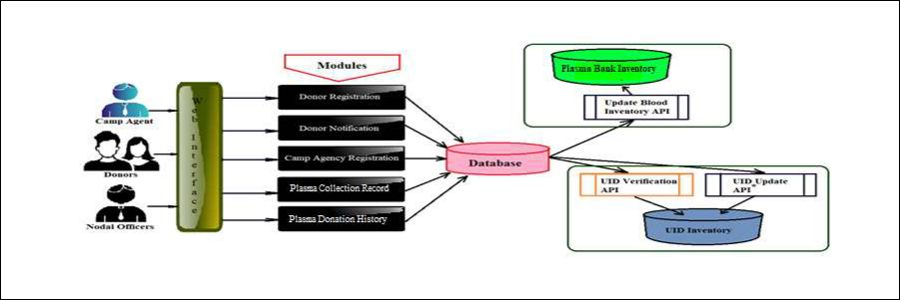

Level 2

User Stories Plasma Bank

The following are the list of all the user stories for the product.

User Type | Functional | User Story | User Story / Task
 | Requirement | Number
 | (Epic)
Donor | App Registration | USN-1 | As a User, I can register for the application by
 |  |  | entering my email, password, and confirming
 |  |  | my password.
 | Login | USN-2 | As a User, I can log into the application by
 |  |  | entering email & password.
 | Register for | USN-3 | As a User, I can log into the application and
 | Donate |  | find the current bank to donate plasma and
 |  |  | confirm my booking.
Patient/Doctor | Find the Bank | USN-4 | As a User, I can directly access the
 |  |  | application and find the plasma available
 |  |  | bank.
 | Request for | USN-5 | As a User, I can enter into the application and
 | Plasma |  | find the current bank and request for plasma
 |  |  | and state the emergency.
Administrator | Maintain the | USN-6 | As Administrator, I can log into the application
 | Applications |  | by entering my email, password and
 |  |  | maintaining details for users.
 | Connect to Bank | USN-7 | As Administrator, I can hold the good
 | with Users |  | communication between bank and user.
 | Maintain | USN-8 | As Administrator, I can hold the exact details
 | Database |  | of donor and patient and also bank for
 |  |  | requesting and available of plasma.
Plasma Bank | Connect the Bank | USN-7 | As Bank, I can hold the good communication
 | with Users |  | between administrator and user.
 | Maintain | USN-8 | As Bank, I can hold the details of donor and
 | Database |  | patient and also bank for requesting and
 |  |  | available of plasma.
BOT | Help the User my | USN-9 | As AI BOT, I can hold the good
 | BOT message in |  | communication between bank and user also
 | Application |  | help the user.


Acceptance criteria | Priority | Release
I can access my Account / | High | Sprint-1
Dashboard.
I can receive confirmation | High | Sprint-2
Email & click confirm.
I can register & access the | Medium | Sprint-3
Dashboard with their
Login.
I can access my Account / | High | Sprint-1,2
Dashboard.
I can register & access the | Medium | Sprint-3
Dashboard with their
Login.
I can access my Account / | High | Sprint-3
Dashboard.
I can access my Account / | Low | Sprint-4
Dashboard.
I can access my Account / | Medium | Sprint-4
Dashboard.
I can access my Account / | Medium | Sprint-3
Dashboard.
I can access my Account / | High | Sprint-4
Dashboard.
I can access my Account / | Medium | Sprint-4
Dashboard.


